The tests for date() system call is written in date_testing.c file. The following conditions were tested in date_testing.c
a. Correct type of argument is passed to date() system call
b. Uninitialized pointer is passed to date() system call
c. No argument is passed to date() system call
d. Int type of pointer is passed to date() system call.

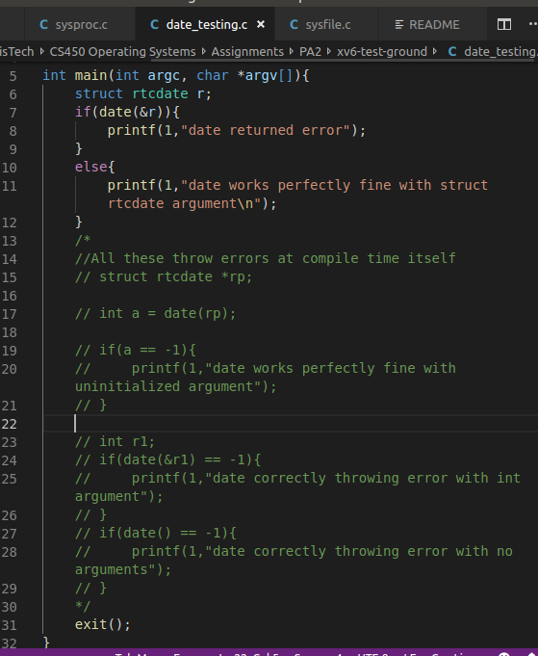

Although code works perfectly fine for test case a, for test cases b,c,d the xv6 throws errors at compile time itself complaining about the argument mismatch. Hence we will not get a chance to test for the return type by providing invalid arguments. Hence I have have commented all these test cases. Also, we can say that since these test cases are throwing errors because they do not match with date system call, date() works perfectly fine. Uncommenting these will cause “make qemu-nox” to fail with compile time errors.

